How to run UI automate test for login

1. For initialization, I have changed SDK version and added espresso library in build.gradle as snapshot below. So the program will download or sync them automatically if you don’t have the same version in this setting.

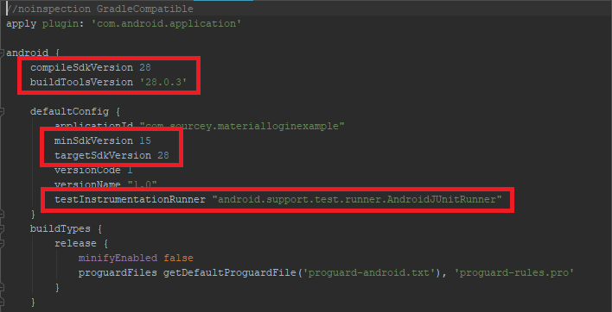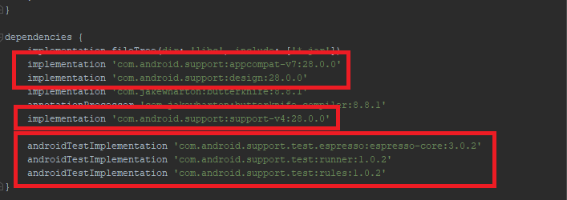

1. You must have a virtual devices for running test, I use device as snapshot below and I’m not sure that the other virtual devices with difference setting from mine can run properly.

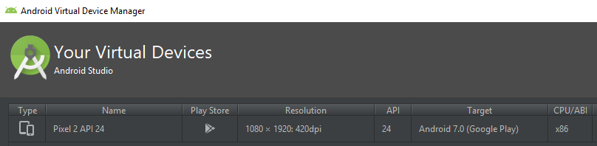

1. When everything is ready, please run LoginActivityTest.java for testing and then you can see the UI automation will be run as snapshot below.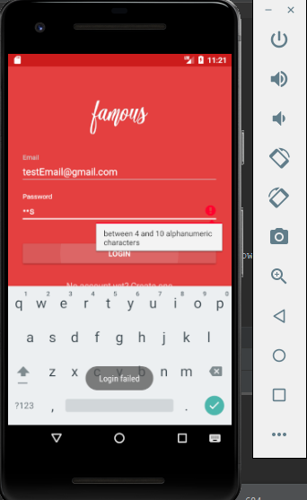

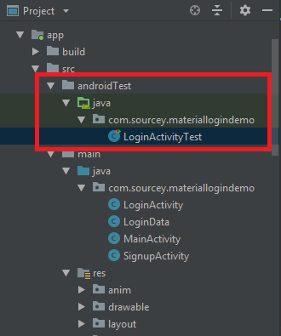

1. Last step, you can real time monitor the test result of each cases at the left-bottom corner in Android Studio. If you need more details about each cases, please see them in TestCase_Table.xlsx file.

